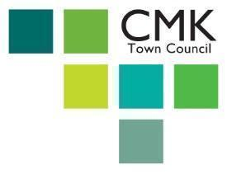  

**You are hereby summoned to attend a meeting of the Central Milton Keynes Town Council Planning Committee to be held at 6.10pm**

**TUESDAY 16th September 2025**

**CENTRECOM MEETING PLACE**

**602 NORTH ROW**

**CENTRAL MILTON KEYNES**



**Paul Cranfield**

**Clerk**

**9/09/2025**

**Members of the public are welcome to attend Town Council meetings.**

**Only items listed on this agenda will be discussed.**

**Items indicated with an * will have accompanying papers.**

**Agenda**

P25/038 (6.10) To note apologies for absence

P25/039 (6.10) To record declarations of interest from members in respect of any

item to be discussed

*(The meeting will be adjourned for an agreed time by the Chair for the public to ask questions about agenda items. Following timings to be adjusted as required.)*

P25/040 (6.12) To approve the minutes of the meeting held on 19 August 2025*

P25/041 (6.15) Minor planning applications for ratification*

P25/042 (6.20) To consider DLP report on PLN/2025/0703 OPP Campbell Park Northside Phases 2-5- Traffic analysis in relation to proposed ‘at-grade’ crossing at Skeldon Gate*

P25/043 (6.35) To consider response to planning application PLN/2025/1626-

Demolition of Sainsbury's Argos building and construction of a part 18, part 13 and part 10 storey residential apartment building comprising 350 units & ancillary works*

P25/044 (7.10) To note Objection re PLN/025/0703*

**Date and time of next scheduled meeting- TUESDAY 21st October 2025 at 6.10 pm at Centrecom Meeting Place.**