**Milton Keynes Council**

**Step by Step Guide on how to Report Issues**

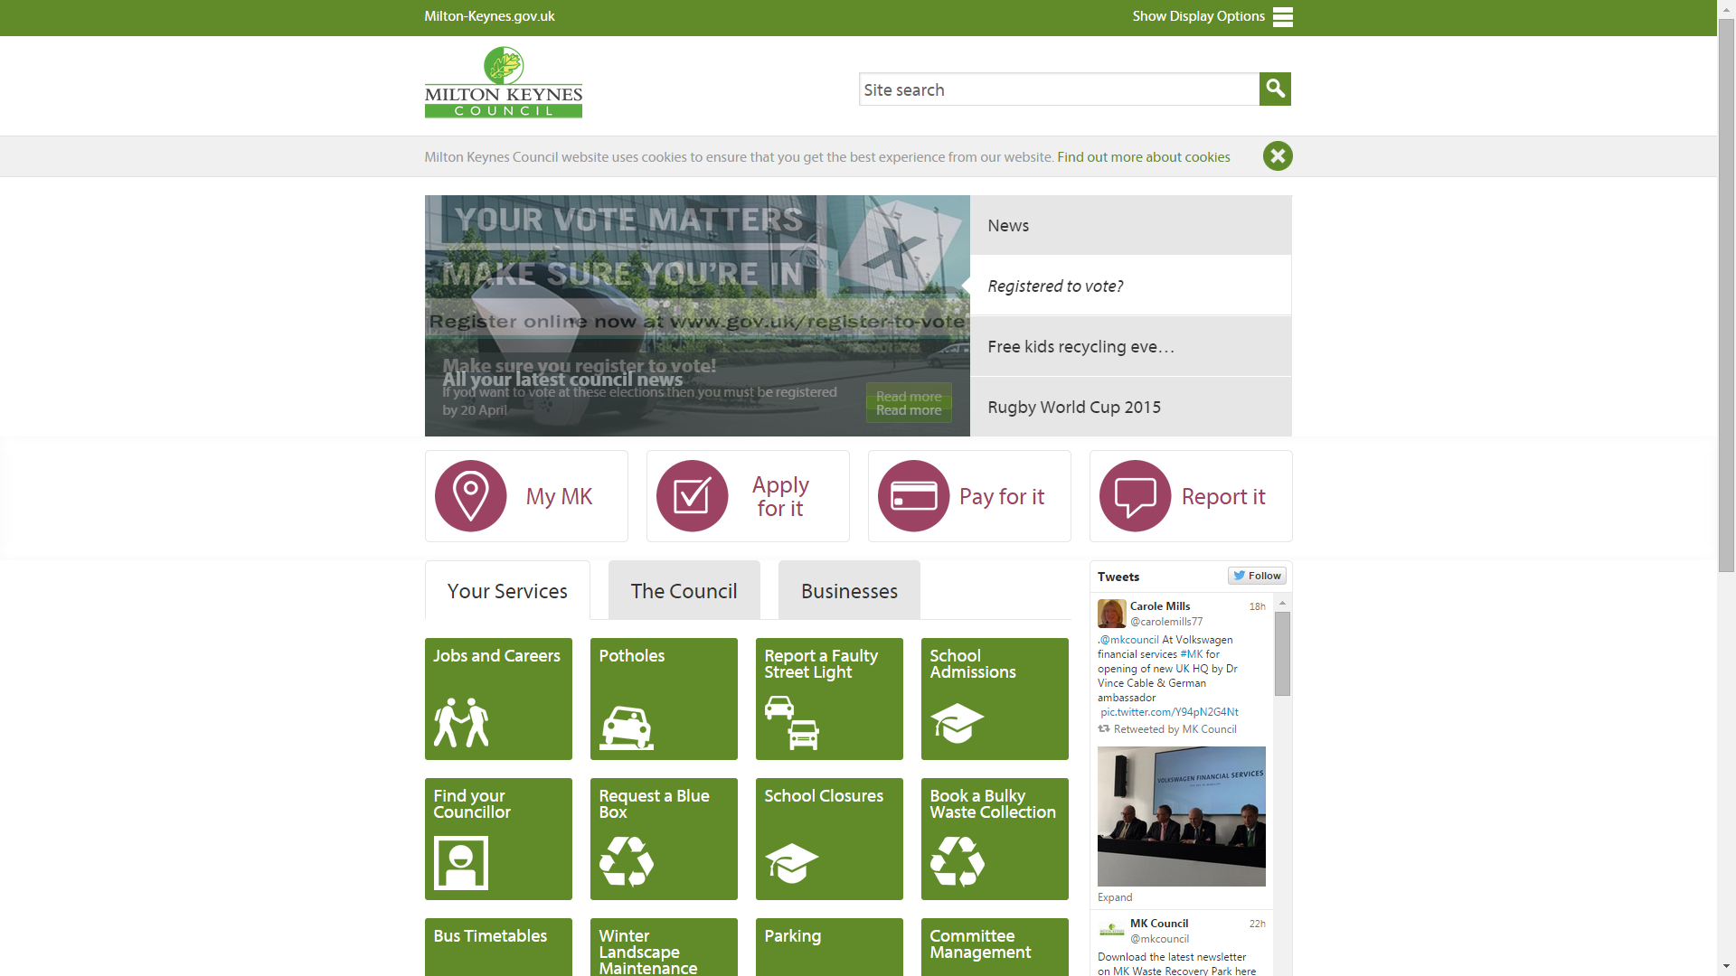

Log onto Milton Keynes Councils home page and click onto the Report it button

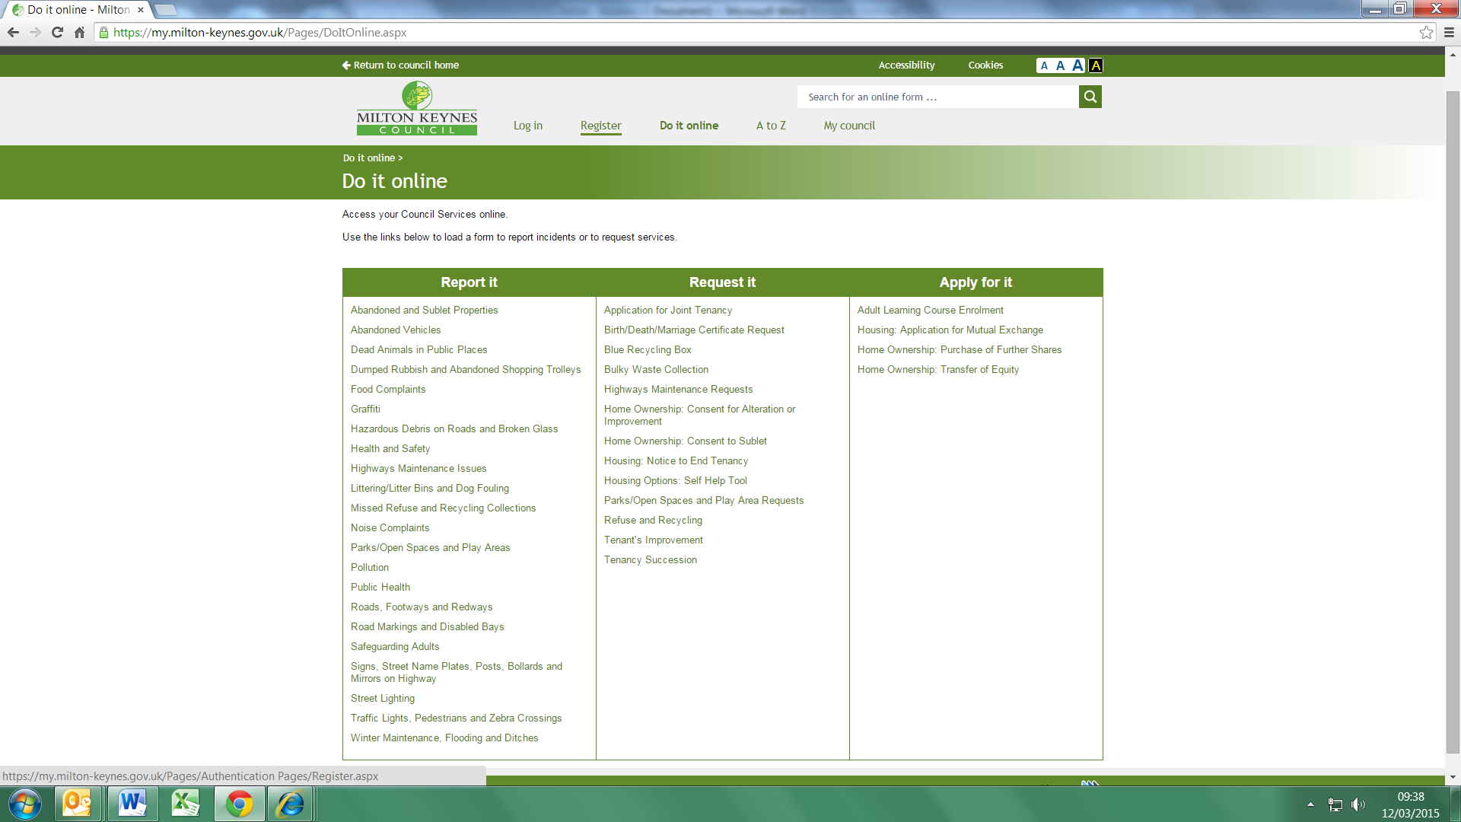

If you don’t already have an account you will need to ‘Register’ first.

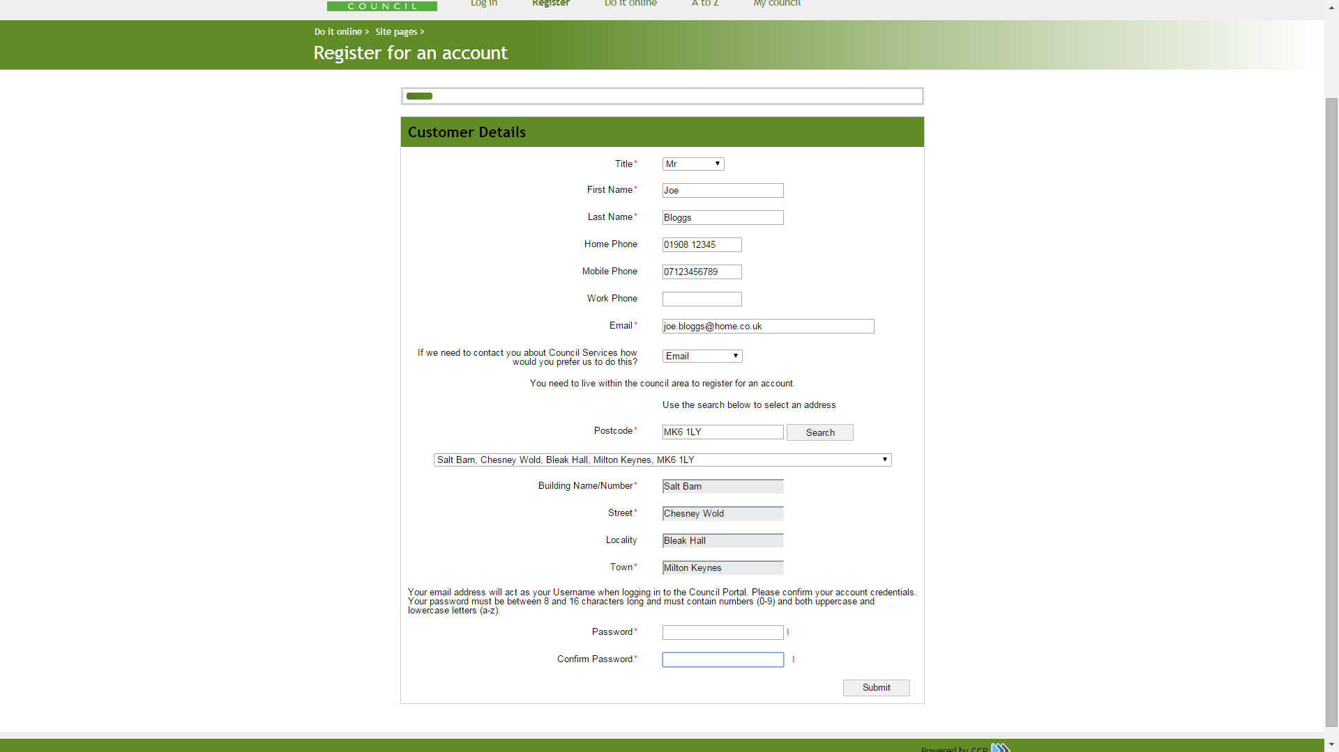

Complete the customer details form and submit

You will be sent a verification email with a link that you will need to click on in order to finish the account set up process.

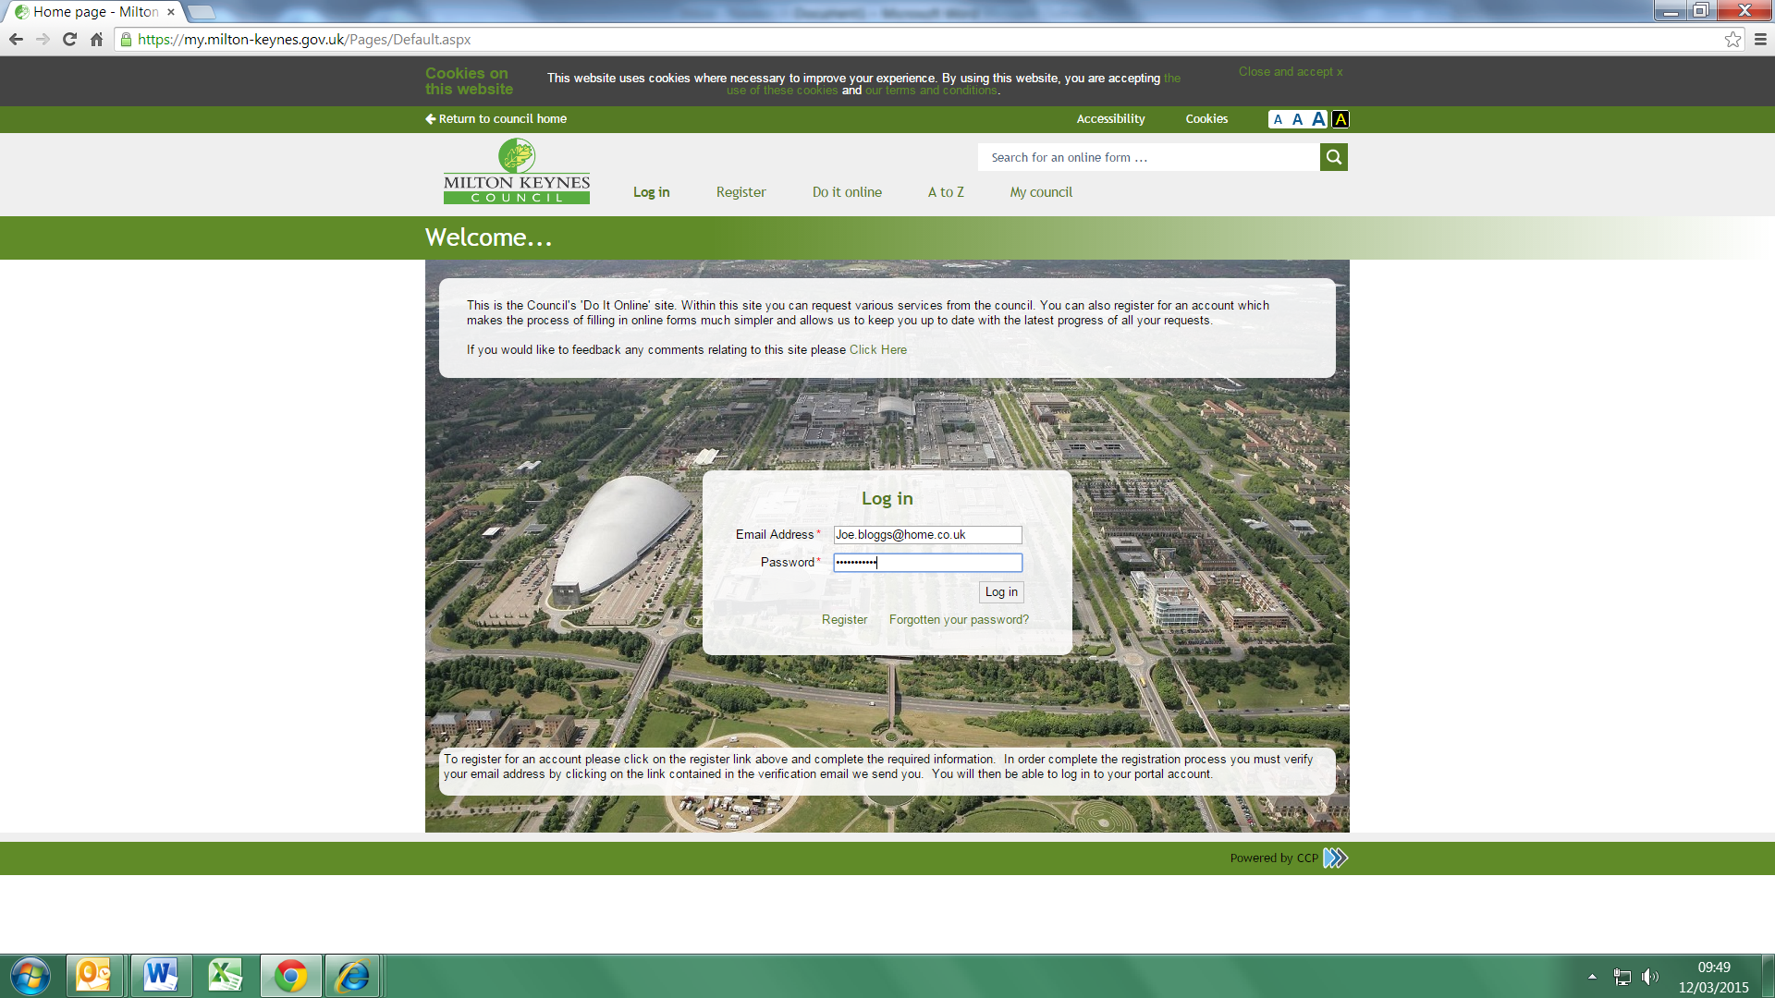

Once you have created your account, log into the system to start the reporting procedure

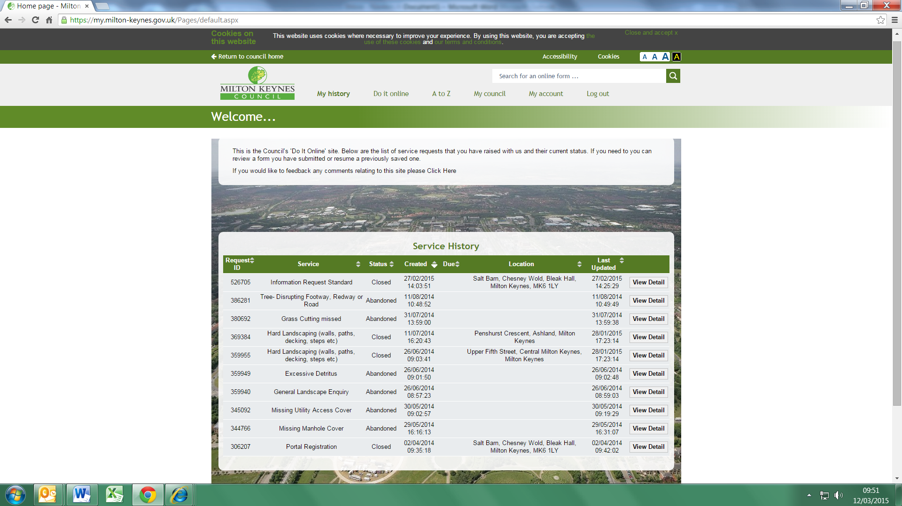

If you have reported previously, your reporting history may be displayed

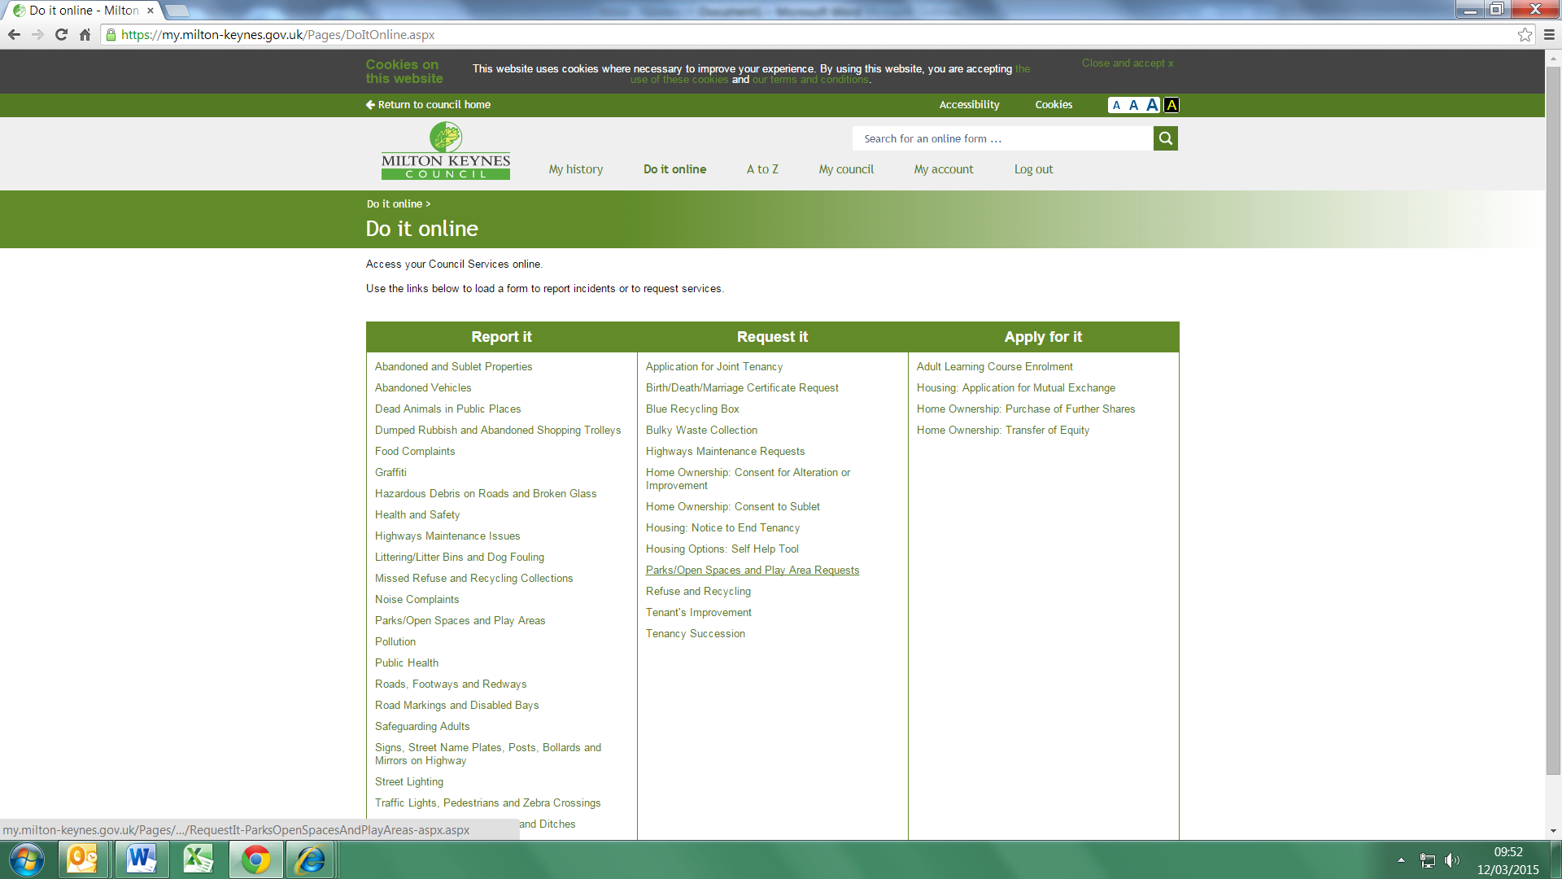

To begin the process for reporting, click ‘Do it online’ and select one of the categories from the ‘Report it’ section

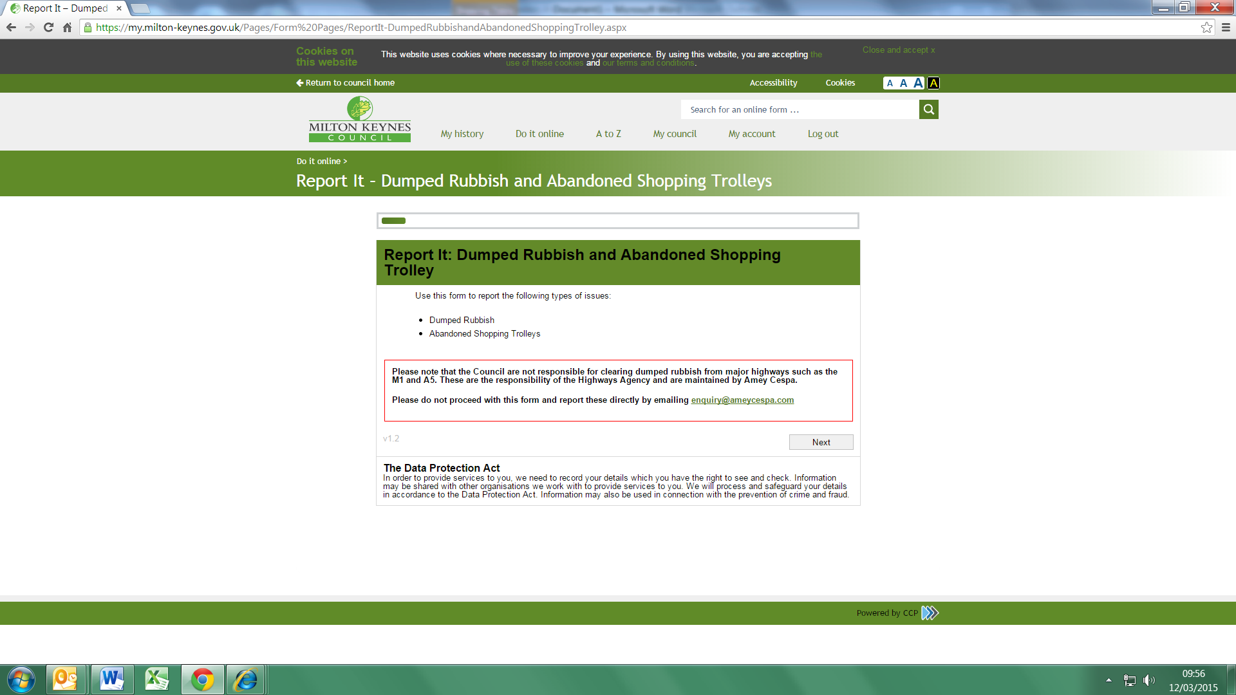

Depending on what you are reporting you will be asked to select different categories



You will be asked to verify your details

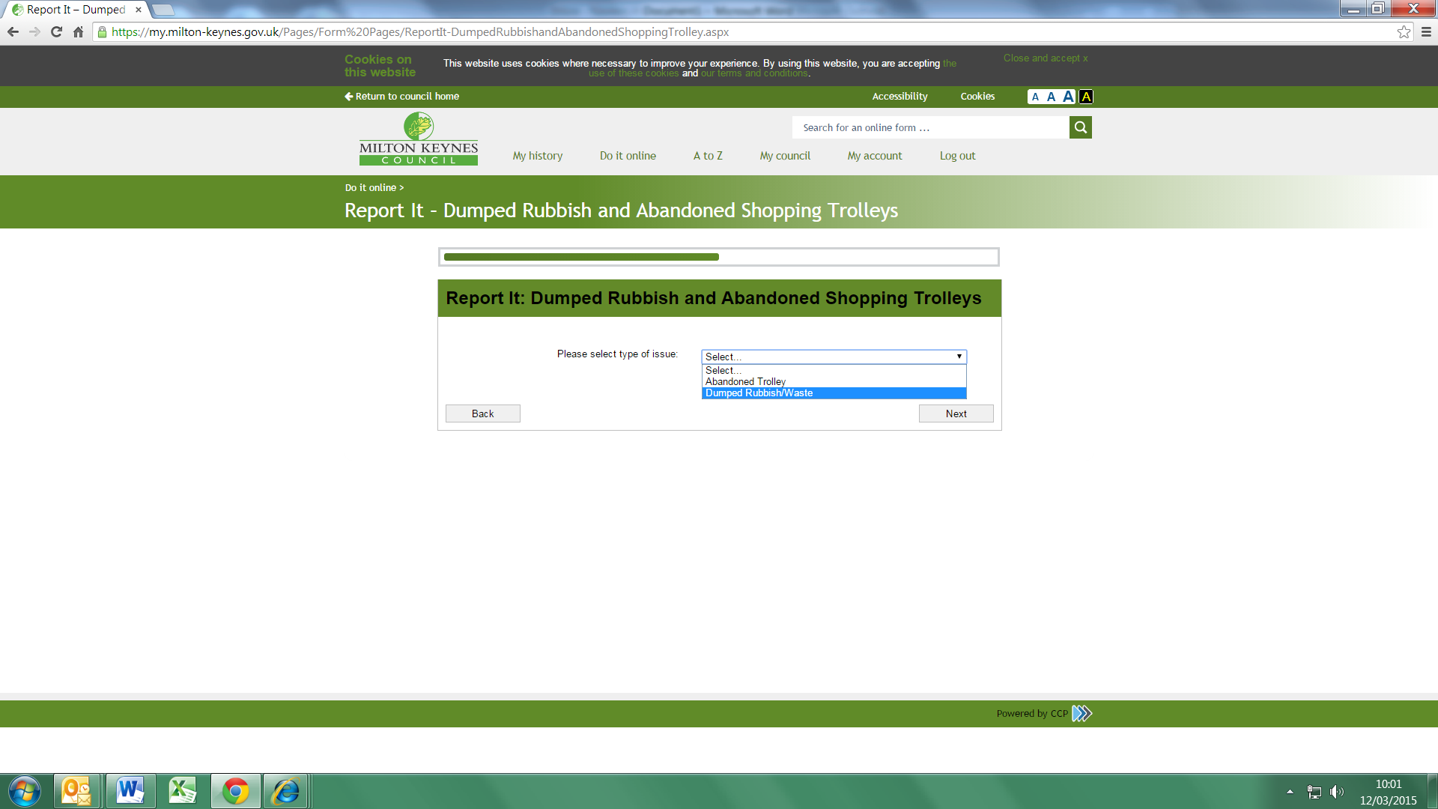

Continue to follow instructions

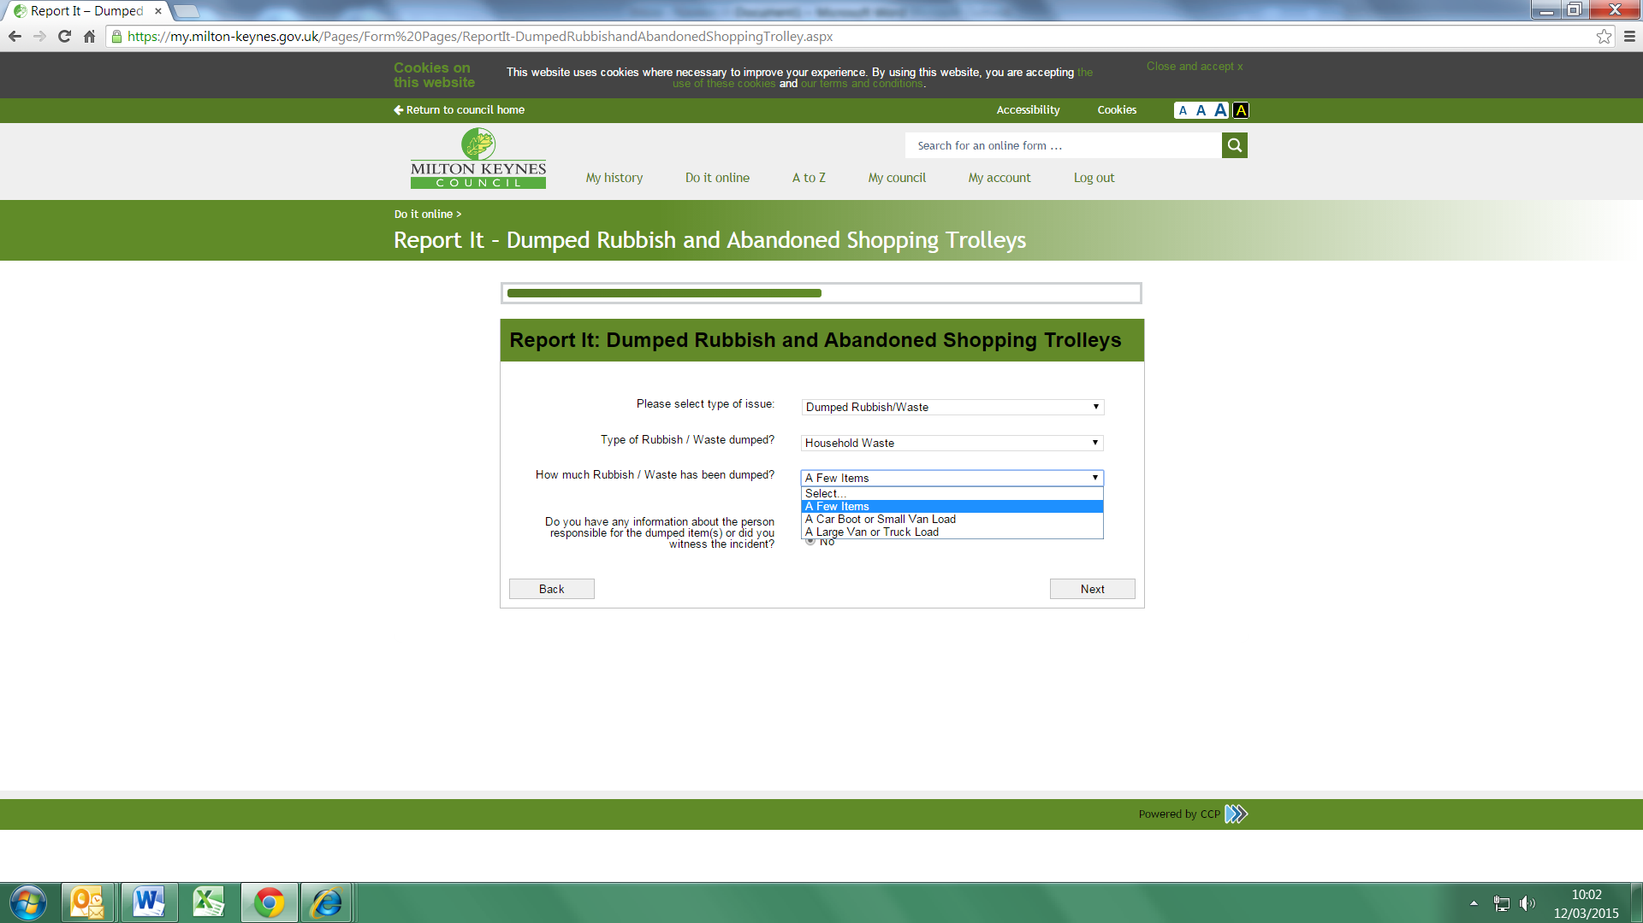

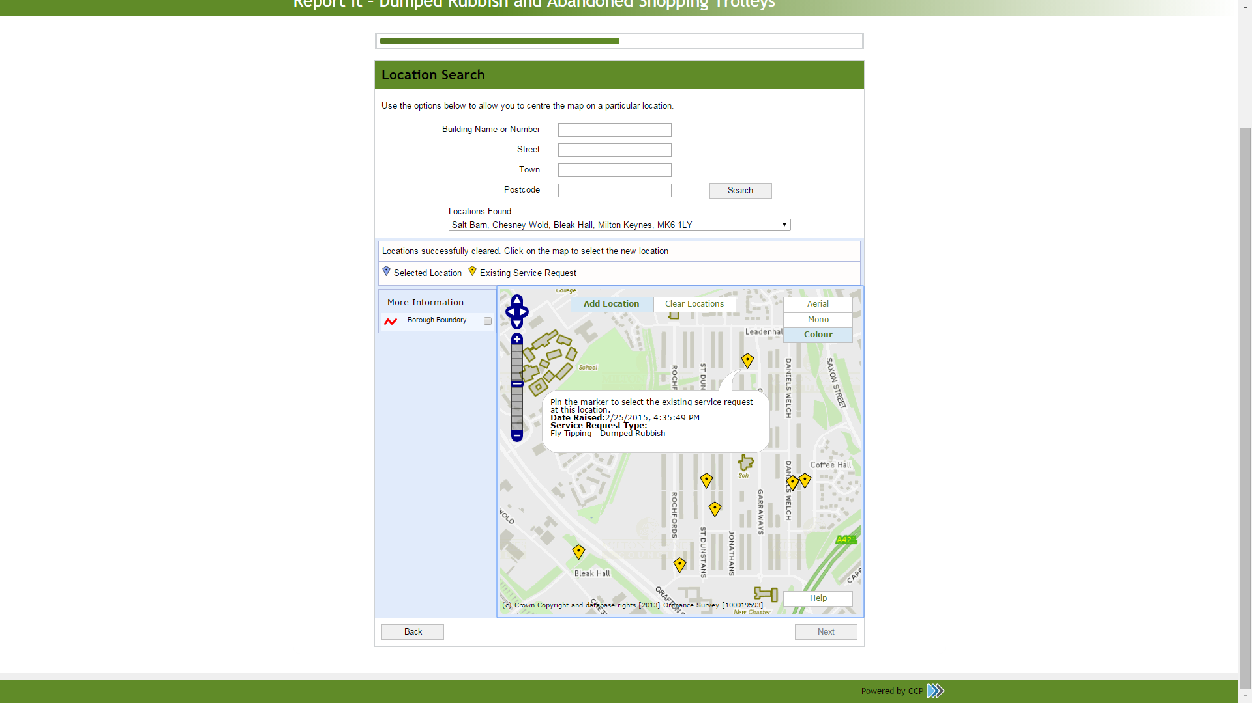

Use arrows or drag the map to identify the location and zoom in

If you are reporting something and there is already a yellow kite on the location it means it has already been reported

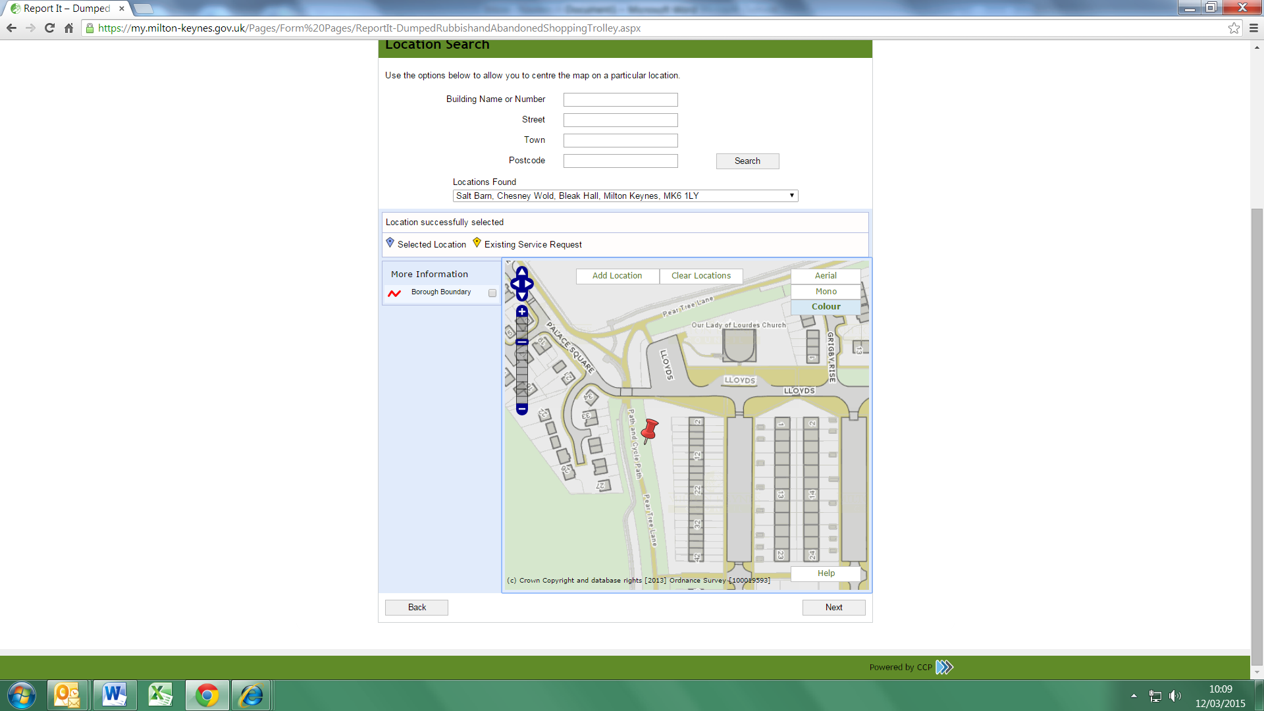

Pin point the exact location where the issue is and click, a red pin will appear on screen.

You can remove & relocate the pin using the ‘clear location’ tab.

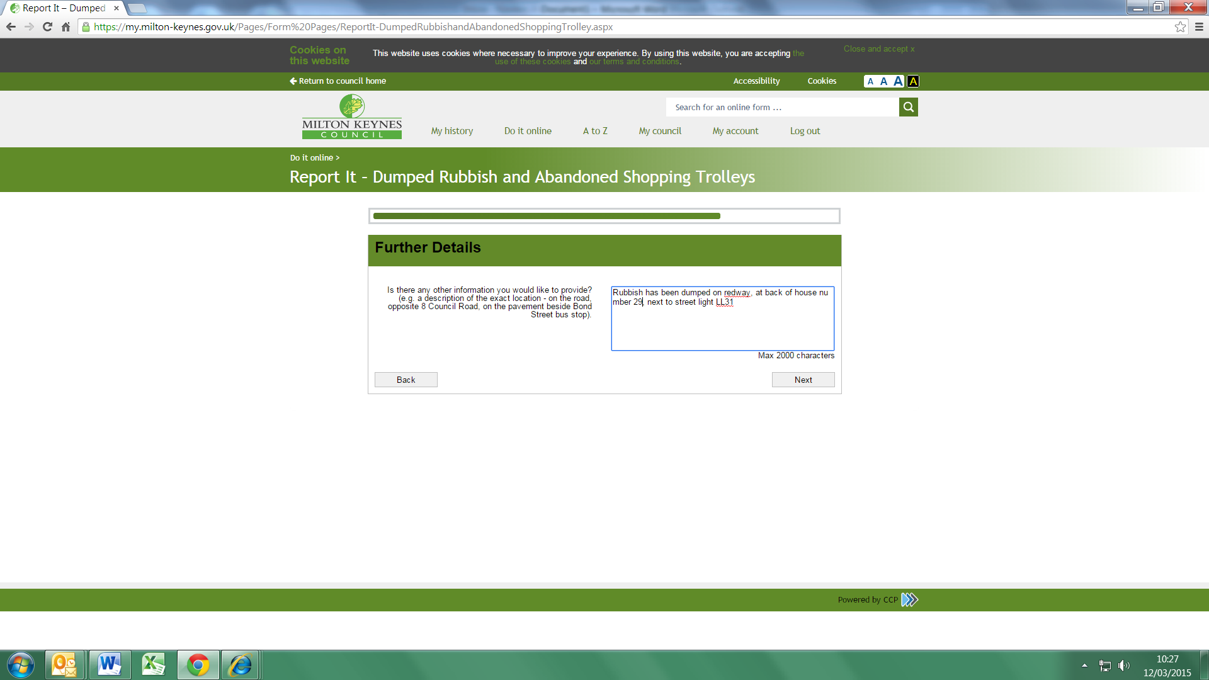

Give as much additional information as possible to explain & locate the issue

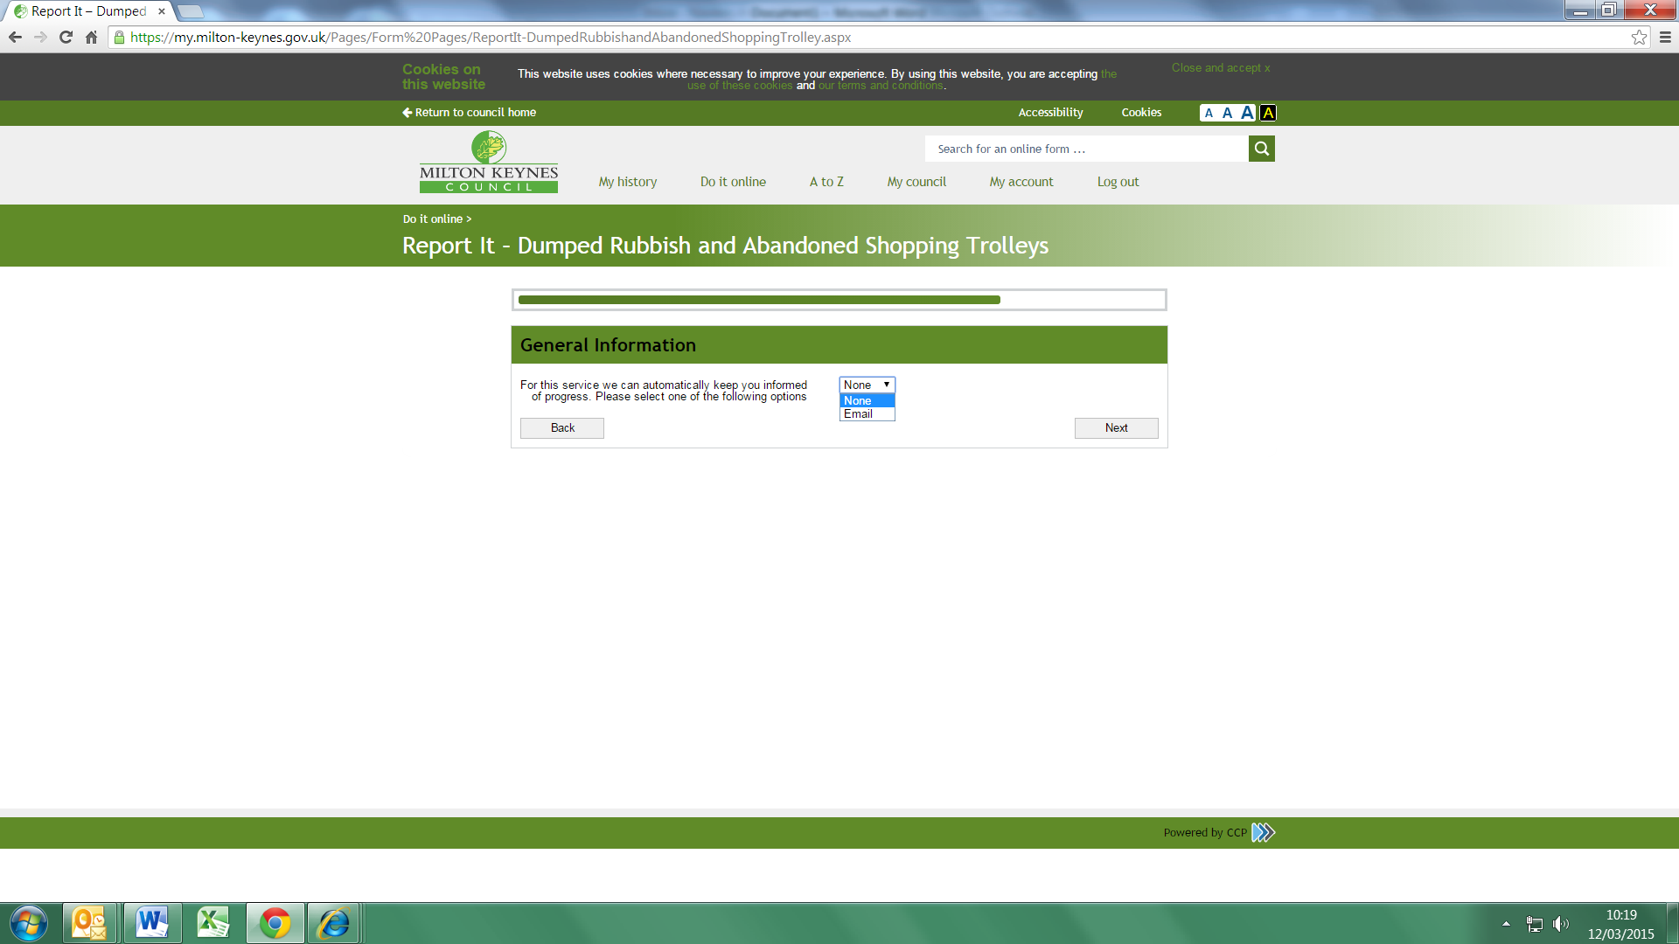

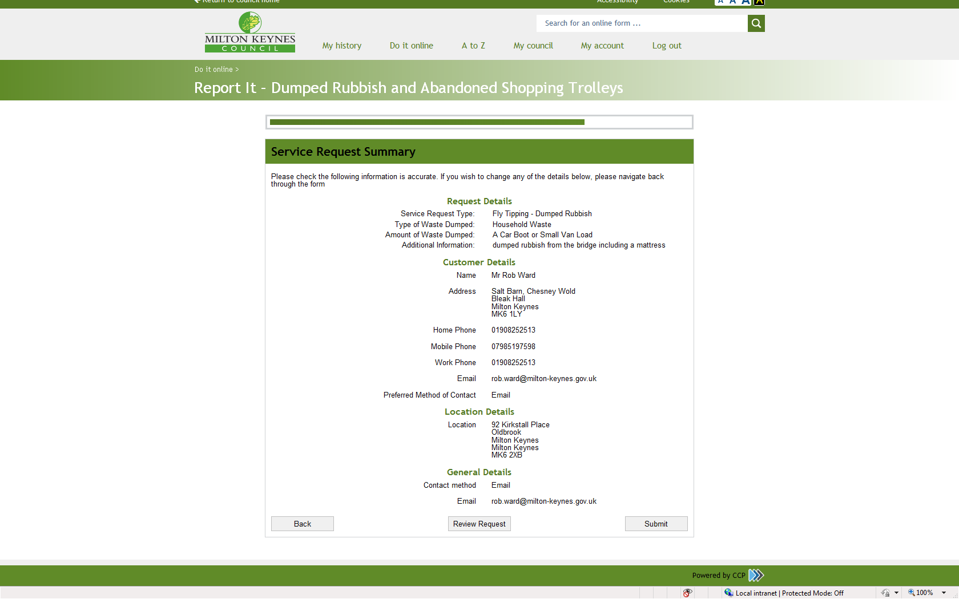

You will be shown a summary of the details you have given.

Finally click the submit button.